

|  |  |
| --- | --- |
| **ASSIGNMENT** | |
| **Course Code** | **19CSC302A** |
| **Course Name** | **Database Systems** |
| **Programme** | **B. Tech** |
| **Department** | **Computer Science and Engineering** |
| **Faculty** | **Engineering and Technology** |

#### 

|  |  |
| --- | --- |
| **Name of the Student** | **Deepak R** |
| **Reg. No** | **18ETCS002041** |
| **Semester/Year** | **5th/2020** |
| **Course Leader/s** | **Ami Rai E** |

|  |  |  |  |  |  |  |  |  |
| --- | --- | --- | --- | --- | --- | --- | --- | --- |
| **Declaration Sheet** | | | | | | | | |
| Student Name | **Deepak R** | | | | | | | |
| Reg. No | **18ETCS002041** | | | | | | | |
| Programme | **B. Tech** | | | | | Semester/Year | **5th/2020** | |
| Course Code | **19CSC302A** | | | | | | | |
| Course Title | **Database Systems** | | | | | | | |
| Course Date |  | | to | |  | | | |
| Course Leader | **Mrs Ami Rai E** | | | | | | | |
| **Declaration**  The assignment submitted herewith is a result of my own investigations and that I have conformed to the guidelines against plagiarism as laid out in the Student Handbook. All sections of the text and results, which have been obtained from other sources, are fully referenced. I understand that cheating and plagiarism constitute a breach of University regulations and will be dealt with accordingly. | | | | | | | | |
| Signature of the Student | |  | | | | | Date | 28/11/2020 |
| Submission date stamp  (by Examination & Assessment Section) | |  | | | | | | |
| Signature of the Course Leader and date | | | | Signature of the Reviewer and date | | | | |
|  | | | |  | | | | |

|  |  |  |  |
| --- | --- | --- | --- |
|  | **Faculty of Engineering & Technology** | | |
|  | **Ramaiah University of Applied Sciences** | | |
| **Department** | Computer Science **Programme** B. Tech. Computer Science and  Engineering Engineering | | |
| **Semester/Batch** | 5th/2018 | | |
| **Course Code** | 19CSC302A | **Course Title** | Database Systems |
| **Course Leader(s)** | A. Prabhakar, Gp Capt N Rath VSM, Ami Rai E. | | |

|  |  |  |  |  |  |  |  |  |
| --- | --- | --- | --- | --- | --- | --- | --- | --- |
| **Assignment - 01** | | | | |  | |  |  |
| Register No. | | | **18ETCS002041** | Name of Student |  | **Deepak R** |  |  |
| **Sections** |  | **Marking Scheme** | | | **Max Marks** | | **First Examiner**  **Marks** | **Second Examiner**  **M**  **arks** |
| **Part**  **A** | A.1 | Merits and demerits of relational and graph databases | | | 02 | |  |  |
| A.2 | Justification of the stance taken and conclusion | | | 03 | |  |  |
|  | **Part-A Max Marks** | | | **05** | |  |  |
| **Part B**  **1** | B1.1 | List of functional and data requirements | | | 03 | |  |  |
| B1.2 | Discussion on the entities, attributes, and relationships | | | 02 | |  |  |
| B1.3 | ER diagram | | | 02 | |  |  |
| B1.4 | Identification of any requirement that is not possible to model using ER diagram | | | 03 | |  |  |
|  | **B1 Max Marks** | | | **10** | |  |  |
| **Part B**  **2** | B2.1 | Design of database schema | | | 03 | |  |  |
| B2.2 | Discussion on the constraints | | | 02 | |  |  |
| B2.3 | Implementation using SQL commands | | | 02 | |  |  |
| B2.4 | Update operations violating the schema constraints | | | 03 | |  |  |
|  | **B2 Max Marks** | | | **10** | |  |  |
|  | **Total Assignment Marks** | | | | **25** | |  |  |

|  |  |  |  |  |
| --- | --- | --- | --- | --- |
| **Course Marks Tabulation** | | | | |
| **Component-**  **1(B)Assignment** | **First**  **Examiner** | **Remarks** | **Second Examiner** | **Remarks** |
| A |  |  |  |  |
| **Marks (out of 10)** |  |  |  |  |
| Signature of First Examiner Signature of Second Examiner | | | | |

**Please note:**

1. Documental evidence for all the components/parts of the assessment such as the reports, photographs, laboratory exam / tool tests are required to be attached to the assignment report in a proper order.
2. The First Examiner is required to mark the comments in RED ink and the Second Examiner’s comments should be in GREEN ink.
3. The marks for all the questions of the assignment have to be written only in the **Component – CET B: Assignment** table.
4. If the variation between the marks awarded by the first examiner and the second examiner lies within +/- 3 marks, then the marks allotted by the first examiner is considered to be final. If the variation is more than +/- 3 marks then both the examiners should resolve the issue in consultation with the Chairman BoE.

**Assignment - 01**

**Instructions to students:**

1. The assignment consists of **3**questions: Part A –**1** Question, Part B- **2**Questions.
2. Maximum marks is **25**.
3. The assignment has to be neatly word processed as per the prescribed format.

# Submission Date: 28/11/2020

1. **Submission after the due date is not permitted.**
2. **IMPORTANT**: It is essential that all the sources used in preparation of the assignment must be suitably referenced in the text.
3. Marks will be awarded only to the sections and subsections clearly indicated as per the problem statement/exercise/question

**Solution for PART A**

***“Can graph databases replace relational database technologies”.***

**Introduction**

A graph database is a data management system software. The building blocks are vertices and edges. To put it in a more familiar context, a relational database is also a data management software in which the building blocks are tables. Both require loading data into the software and using a query language or APIs to access the data.

Relational databases boomed in the 1980s. Many commercial companies (i.e. Oracle, Ingres, IBM) backed the relational model (tabular organization) of data management. In that era, the main data management need was to generate reports.

Graph databases didn't see a greater advantage over relational databases until recent years, when frequent schema changes, managing explosives volume of data, real-time query response time, and more intelligent data activation requirements make people realize the advantages of the graph model.

Graph DB technology is being rapidly commoditised with platforms like [Neo4J](http://neo4j.com/) and [OrientDB](http://www.orientechnologies.com/orientdb/" \t "_blank)leading the way. I believe they will become a new defacto standard in developing all sorts of business and online applications once the inertia of 30+ years of RDBMS thinking is slowly broken down.

**Merits and demerits of relational and graph databases**

## [**Advantages and Disadvantages of using relational databases**](http://maxlogix.blogspot.com/2009/09/advantages-and-disadvantages-of-using.html)

**Relational Database**

**Advantages:**

1. Ease of use: The revision of any information as tables consisting of rows and columns is much easier to understand .

2. Flexibility: Different tables from which information has to be linked and extracted can be easily manipulated by operators such as project and join to give information in the form in which it is desired.

3. Precision: The usage of relational algebra and relational calculus in the manipulation of he relations between the tables ensures that there is no ambiguity, which may otherwise arise in establishing the linkages in a complicated network type database.

4.Data Independence: Data independence is achieved more easily with normalization structure used in a relational database than in the more complicated tree or network structure.

5.. Data Manipulation Language: The possibility of responding to query by means of a language based on relational algebra and relational calculus e.g SQL is easy in the relational database approach. For data organized in other structure the query language either becomes complex or extremely limited in its capabilities.

**Disadvantages :**

1. Performance: A major constraint and therefore disadvantage in the use of relational database system is machine performance. If the number of tables between which relationships to be established are large and the tables themselves effect the performance in responding to the sql queries.

2. Physical Storage Consumption:With an interactive system, for example an operation like join would depend upon the physical storage also. It is, therefore common in relational databases to tune the databases and in such a case the physical data layout would be chosen so as to give good performance in the most frequently run operations. It therefore would naturally result in the fact that the lays frequently run operations would tend to become even more shared.

3. Slow extraction of meaning from data:  if the data is naturally organized in a hierarchical manner and stored as such, the hierarchical approach may give quick meaning for that data.

**Graph Database**

**Advantages**:

1.Really fast queries when you are looking for relationships between nodes  
2.Really fast to traverse nodes  
3.Can represent multiple dimensions

**Disadvantages :**

1.Inappropriate for transactional information, like accounting records where relationships between records are simpler  
2.Harder to do summing queries and max queries efficiently - counting queries not harder  
3.Usually need to learn a new query language like CIPHER  
4.Fewer vendors to choose from, and smaller user base, so harder to get support when you run into issues

**Justification of the stance taken and conclusion with example**

It depends on what type of data we want to store.

For example if we have financial data like income of people, their social security number and address data a relational database would be appropriate because we can store that information in simple tables and the data from one person is rarely connected in any way to the data of another person.

But if we want to create a network of information, maybe the relationships between our friends and family, a graph database would be the oppportunity to choose because we can display connections between things (nodes) in a very simple way via edges.

In a relational database you would need different tables and connect them through complicated queries.

Hierarchical datasets easily highlight the modelling and query execution differences in both relational and graph databases. However, **this is by no means an indication that you should start throwing away the one database system over the other**. Graph databases are more efficient when data relationships are at the core of our requirement.

**Solution for B.1**

**B1.1 List of functional and data requirements**

## **Functional Requirements for Online Furniture Shopping Management**

### **Table 1.1 Functional Requirement 1**

|  |  |
| --- | --- |
| **Requirement Tag** | **FR1** |
| Requirement Description | The system should have an interface to allow a customer to enter their login credentials/ Create a new Account |
| Dependent on Requirements | NA |
| User/System interacting with the requirement | Customer |

### **Table 1.2 Functional Requirement 2**

|  |  |
| --- | --- |
| **Requirement Tag** | **FR2** |
| Requirement Description | The system should have an interface to allow a customer to add Products(Furniture) in cart |
| Dependent on Requirements | F1 |
| User/System interacting with the requirement | Customer |

### **Table 1.3 Functional Requirement 3**

|  |  |
| --- | --- |
| **Requirement Tag** | **FR3** |
| Requirement Description | The admin must be Provided with Interface to update about Availability of Product(furniture) |
| Dependent on Requirements | F1 |
| User/System interacting with the requirement | admin |

### **Table 1.4 Functional Requirement 4**

|  |  |
| --- | --- |
| **Requirement Tag** | **FR4** |
| Requirement Description | The admin must be be able to view details of Customer. |
| Dependent on Requirements | F1 |
| User/System interacting with the requirement | admin |

### **Table 1.5 Functional Requirement 5**

|  |  |
| --- | --- |
| **Requirement Tag** | **FR5** |
| Requirement Description | The Customer must be able to delete app account if he/she wish |
| Dependent on Requirements | F1 |
| User/System interacting with the requirement | User |

## **Data Requirements for Bank Management System**

### **Table 2.1 Data Requirement 1**

|  |  |
| --- | --- |
| **Requirement Tag** | **DR1** |
| Item Name | CUSTOMER\_ID, Customer\_pass,Customer\_Name,Customer\_Contact |
| Item Description (Where/How used) | The customer will be entering username and password to the system either to Login to Account/ Create a new Account. |
| Item type | Integer, varchar ,string ,Integer |
| User/System interacting with the item | Customer |

### **Table 2.2 Data Requirement 2**

|  |  |
| --- | --- |
| **Requirement Tag** | **DR2** |
| Item Name | CUSTOMER\_ID, Product\_ID,Cat\_Id |
| Item Description (Where/How used) | The customer will be entering Customer\_ID,Product\_ID,Category ID(Cat\_ID) to add product into cart |
| Item type | Integer, Integer,Integer |
| User/System interacting with the item | Customer |

### **Table 2.3 Data Requirement 3**

|  |  |
| --- | --- |
| **Requirement Tag** | **DR3** |
| Item Name | user\_ID, user\_Pswd , Product\_Id |
| Item Description (Where/How used) | The user(admin) must be able to update about availability of Furniture(Product) using user\_ID, user\_Pswd , Product\_Id |
| Item type | Integer, varchar , Integer |
| User/System interacting with the item | admin |

### **Table 2.4 Data Requirement 4**

|  |  |
| --- | --- |
| **Requirement Tag** | **DR4** |
| Item Name | user\_ID, Customer\_Id |
| Item Description (Where/How used) | The user(admin) must be able to view Customer detlails using Customer\_Id |
| Item type | Integer, Integer |
| User/System interacting with the item | admin |

### **Table 2.3 Data Requirement 5**

|  |  |
| --- | --- |
| **Requirement Tag** | **DR5** |
| Item Name | Customer\_id , Customer\_Pass , Customer\_Contact |
| Item Description (Where/How used) | The Customer must be able to delete app account by using Customer\_id , Customer\_Pass and through Customer\_Contact Vrification |
| Item type | Integer, varchar , Integer |
| User/System interacting with the item | user |

**B1.2 Discussion on the entities, attributes, and relationships**

[**Relationships**](https://www.geeksforgeeks.org/attributes-to-relationships-in-er-model/) **are:**

***Cart Filled\_by Customer -> 1 : 1***

One Customer can fill only one product in cart at a time

***Cart Contains product -> 1 : N***

One Cart Contains N number of products

***Products Managed\_BY admins -> N: M***

N number  *admins can manage M number of Products*

***Categories Managed\_BY admins -> N: M***

N number  *admins can manage M number of Catogories .*

***Customer Viewed\_By admins -> N : M***

*M number of admins can view M number of customers details*

***Customer Selects Catagories -> N : M***

N number of Customers Select M number of Categories.

***Customer Buy Products -> N :M***

N Customer can Buy M number of products

**Discussion on the entities and attributes**

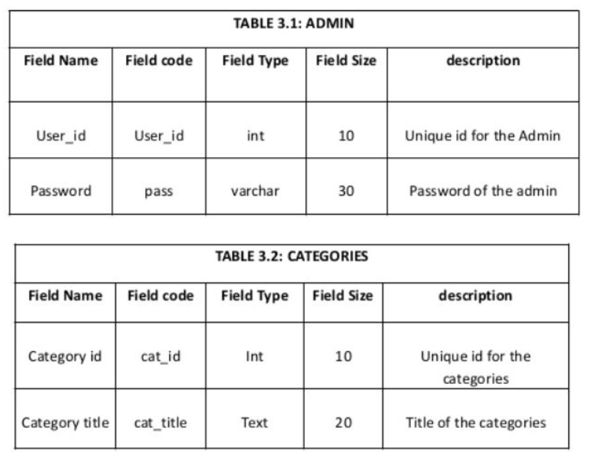

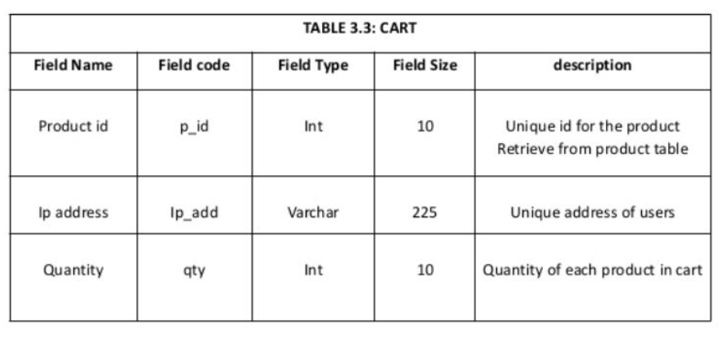

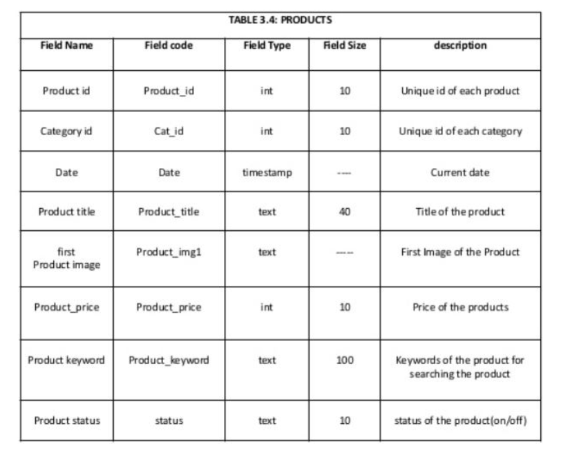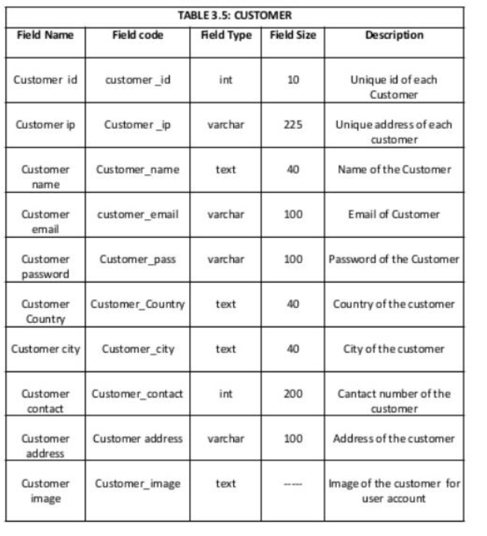

**B1.3 Modelling of ER diagram**

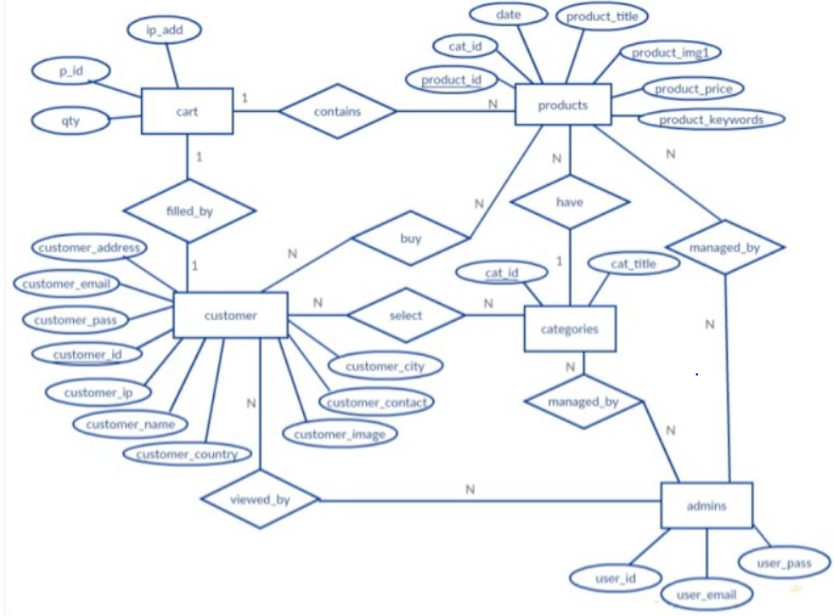

BY DEEPAK R

Product (Furniture)

**B1.4 Identification of any requirements that is not able to capture in the ER**

**diagram and justify the way to solve it using other conceptual data models**

**In ER diagram we cannot represent how the customer can delete account if he don’t need it or about how admins can update the non availability of Furniture or products Specifically we cannot show how the flow take place to solve this problem we can use Block diagramming and user case diagram to represent our flow of work.**

**Block diagramming**

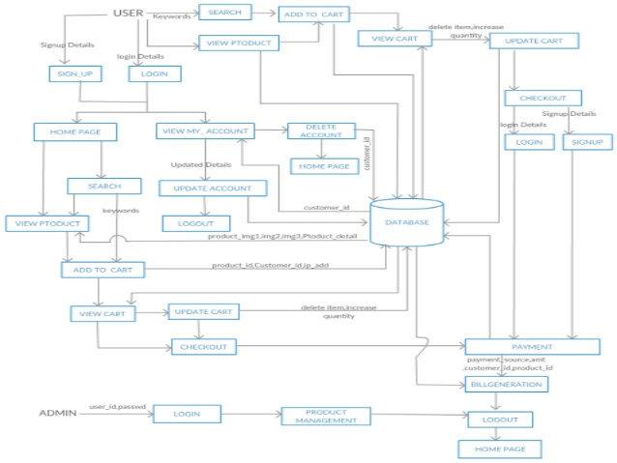User case Diagram

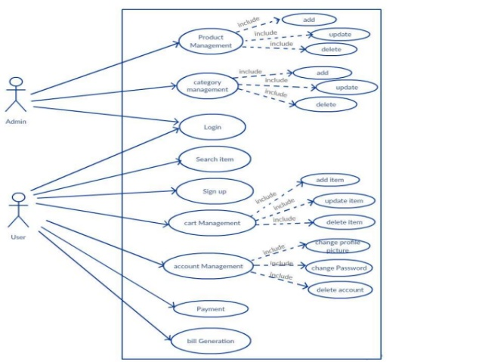

**Solution for B2**

**B2.1 Design of database schema**

**Step1:Mapping of Regular Entity Types**

### **CUSTOMER**

|  |  |  |  |  |  |  |  |  |  |
| --- | --- | --- | --- | --- | --- | --- | --- | --- | --- |
| CUSTOMER\_ID | Customer\_IP | Customer\_Name | Customer\_Email | Customer\_Country | Customer\_Contact | Customer\_Address | Customer\_Image | Customer\_city | Customer\_pas |

* **Admin**

|  |  |  |
| --- | --- | --- |
| User\_ID | User\_pass | User\_email |

* **Categories**

|  |  |
| --- | --- |
| Cat\_ID | Cat\_titte |

* **Cart**

|  |  |  |
| --- | --- | --- |
|  | qty | Ip\_add |

### **Product**

|  |  |  |  |  |  |  |
| --- | --- | --- | --- | --- | --- | --- |
| Product\_ID | Product\_date | Product\_tittle | Product\_Price | Product\_Keyword | Product\_imag | Product\_Status |

Step2:Mapping of Weak EntityTypes

* Not applicable as there are no weak entity types identified.

Step3:Mapping of Binary 1:1 Relation Types

* ***Cart Filled\_by Customer -> 1 : 1***

One Customer can fill only one product in cart at a time

In this relationship, entity cart is identified as relation S and entity Customer is identified as relation T. The primary key of T i.e. **Customer\_id** is now included as foreign key **Cust\_id** in S.

Step4:Mapping of Binary 1:N Relationship Types

* ***Cart Contains product -> 1 : N***

One Cart Contains N number of products

In this relationship, entity Cart is identified as relation S and entity Product is identified as relation T. The primary key of T i.e. **Product\_Id** is now included as foreign key **P\_id** in S.

Step5:Mapping of Binary M:N Relationship Types

* ***Products Managed\_BY admins -> N: M***

N number  *admins can manage M number of Products So the Primary keys of Products and admins are introduced as foreign keys in Managed\_By Relation i.e Product\_id as mProduct\_id and User\_id as mUser\_id.*

* **Managed\_by**

|  |  |
| --- | --- |
| mProduct\_ID | mUser\_id |

* ***Customer Viewed\_By admins -> N : M***

N number  *admins can View M number of Customer details So the Primary keys of Customer and admins are introduced as foreign keys in Viewed\_By Relation i.e Customer\_id as vCustomer\_id and User\_id as vUser\_id.*

* **Viewed\_by**

|  |  |
| --- | --- |
| vCustomer\_ID | vUser\_id |

* ***Customer Selects Catagories -> N : M***

N number of Customers Select M number of Categories. *So the Primary keys of Customers and Categories are introduced as foreign keys in Selects Relation i.e Customer\_id as sCustomer\_id and Categories\_id as sCategories\_id.*

* **Selects**

|  |  |
| --- | --- |
| sCustomer\_ID | sCategories\_id |

* ***Customer Buy Products -> N :M***

N Customer can Buy M number of products. *So the Primary keys of Customers and Products are introduced as foreign keys in Selects Relation i.e Customer\_id as bCustomer\_id and Product\_id as bProduct\_id.*

* **Buy**

|  |  |
| --- | --- |
| bCustomer\_ID | bProduct\_id |

Step6:Mapping of Multivalued attributes

Not applicable as there are no Multivalated attributes identified

## *Step 7: Mapping of N-ary relation types*

Not applicable as there are no N-ary relationships identified.

*The final set of relational schemas obtained after applying the mapping algorithm are: -*

### **CUSTOMER**

|  |  |  |  |  |  |  |  |  |  |
| --- | --- | --- | --- | --- | --- | --- | --- | --- | --- |
| CUSTOMER\_ID | Customer\_IP | Customer\_Name | Customer\_Email | Customer\_Country | Customer\_Contact | Customer\_Address | Customer\_Image | Customer\_city | Customer\_pas |

* **Admin**

|  |  |  |
| --- | --- | --- |
| User\_ID | User\_pass | User\_email |

* **Categories**

|  |  |
| --- | --- |
| Cat\_ID | Cat\_titte |

* **Cart**

|  |  |  |  |  |
| --- | --- | --- | --- | --- |
|  | qty | Ip\_add | Cust\_id | P\_id |

### **Product**

|  |  |  |  |  |  |  |
| --- | --- | --- | --- | --- | --- | --- |
| Product\_ID | Product\_date | Product\_tittle | Product\_Price | Product\_Keyword | Product\_imag | Product\_Status |

* **Managed\_by**

|  |  |
| --- | --- |
| mProduct\_ID | mUser\_id |

* **Viewed\_by**

|  |  |
| --- | --- |
| vCustomer\_ID | vUser\_id |

* **Selects**

|  |  |
| --- | --- |
| sCustomer\_ID | sCategories\_id |

* **Buy**

|  |  |
| --- | --- |
| bCustomer\_ID | bProduct\_id |

**B2.2 Discussion on the schema based constraints applicable for the developed schema**

In Given Schema There are Key Constraints,Referential integrity Constraints,Entity integrity constraints and also Domain Constraints.

In key Constraints Here Primary key Cannot be Null and also it is used to identify specific tuple so its Value Should be unique In given Schema we have Customer\_id,Product\_id user\_id as the Primary keys in customer,Product and admin respectively.

In Entity Integrity Constraints no primary key value can be NULL So Customer\_id,Product\_id user\_id of customer,Product and admin entities respectively cannot be NULL.

In Entity Integrity Constraints the referenced and referencing attributes Value should be Same So For Customer\_id in customer”s Value should be same as SCustomer\_id in Select Relation,Product\_id in Product’s Value Should be Same as BProduct\_id values in Buys relation and s on.

**B2.3 Implementation of relational database schema with appropriate attributes, and constraints using SQL commands**

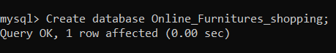

Fig 2.3.1 Created Database named Online\_Furniture\_System

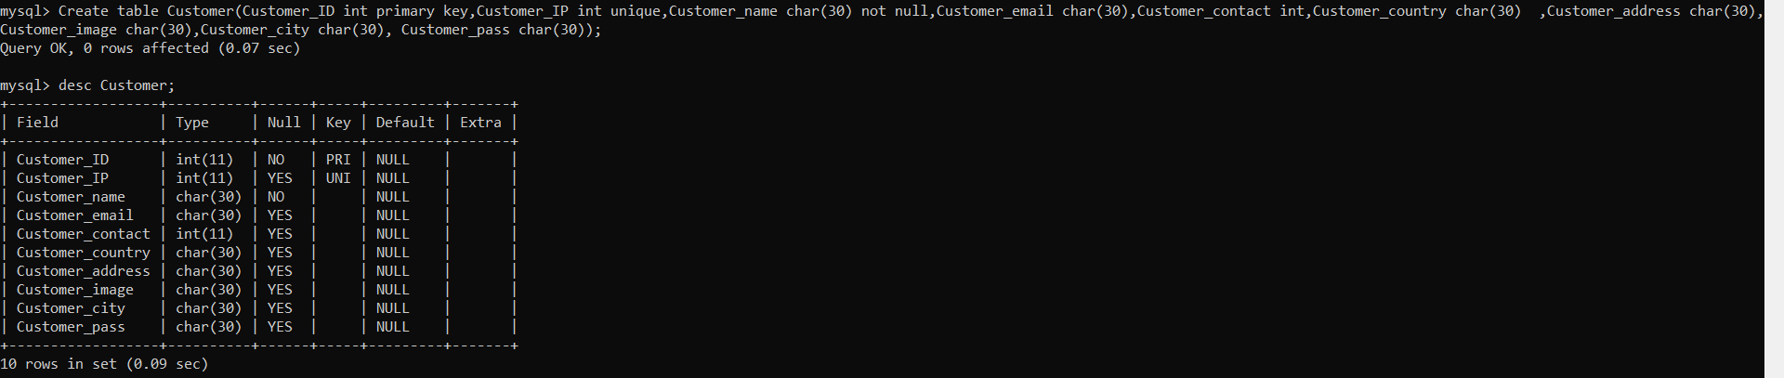

Fig 2.3.2 Created table named Customer with its respective attributes

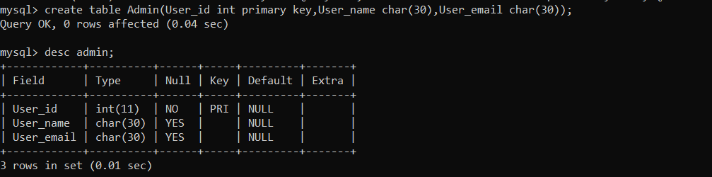

Fig 2.3.3 Created table named Admin with its respective attributes

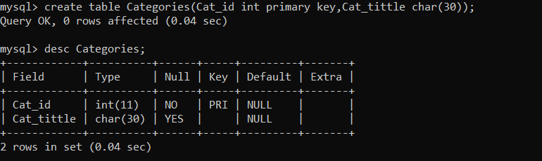

Fig 2.3.4 Created table named Categories with its respective attributes

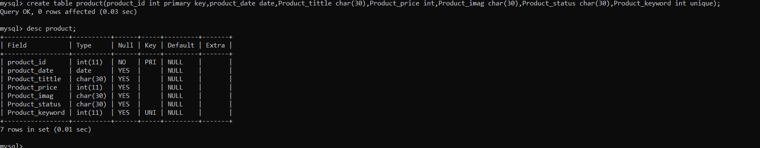

Fig 2.3.5 Created table named Product with its respective attributes

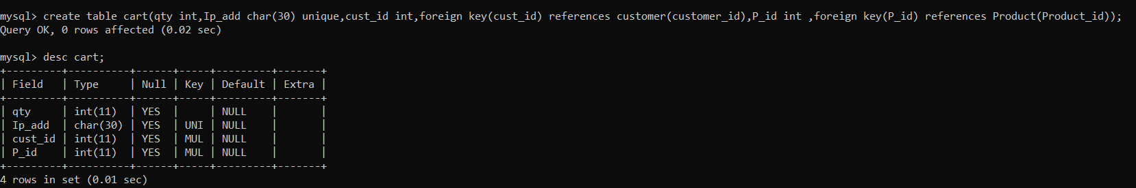

Fig 2.3.6 Created table named cart with its respective attributes

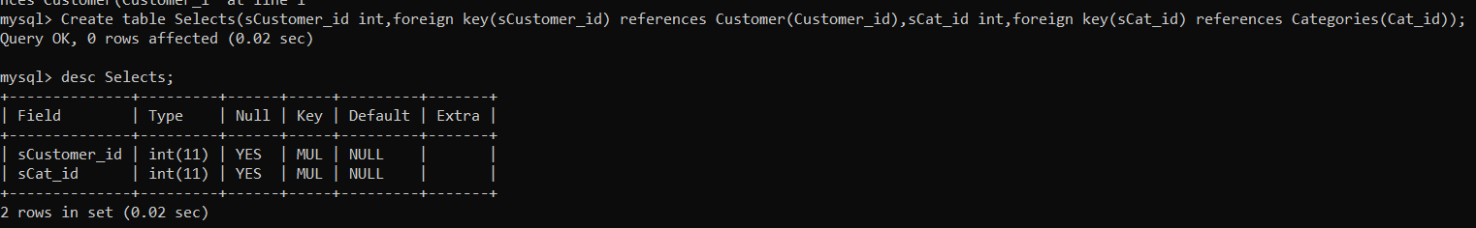

Fig 2.3.7 Created table named Selects with its respective attributes

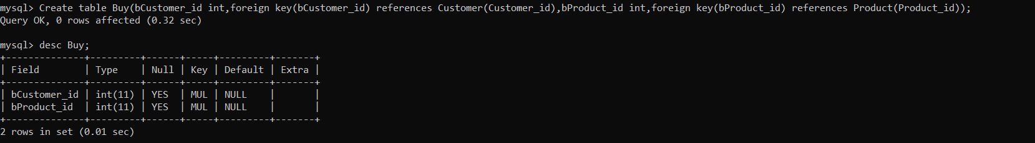

Fig 2.3.8 Created table named Buy with its respective attributes

 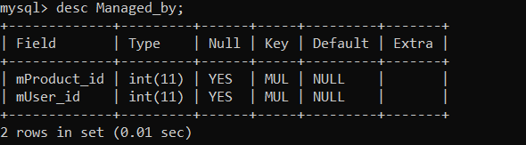

Fig 2.3.9 Created table named Managed\_by with its respective attributes.

B2.4 Show how the update operations violate the schema based constraints by executing SQL commands

To Show where Update Operations Violates Schema Based Constraints we First inserted data into Product,admins,Mnaged\_By entities.

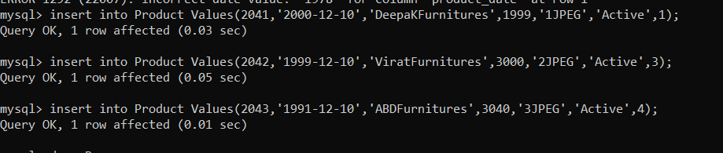

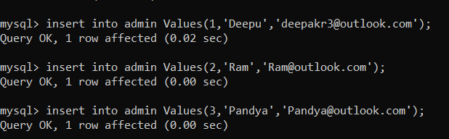

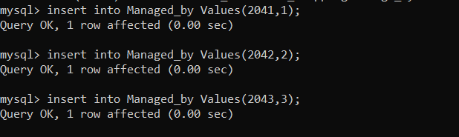

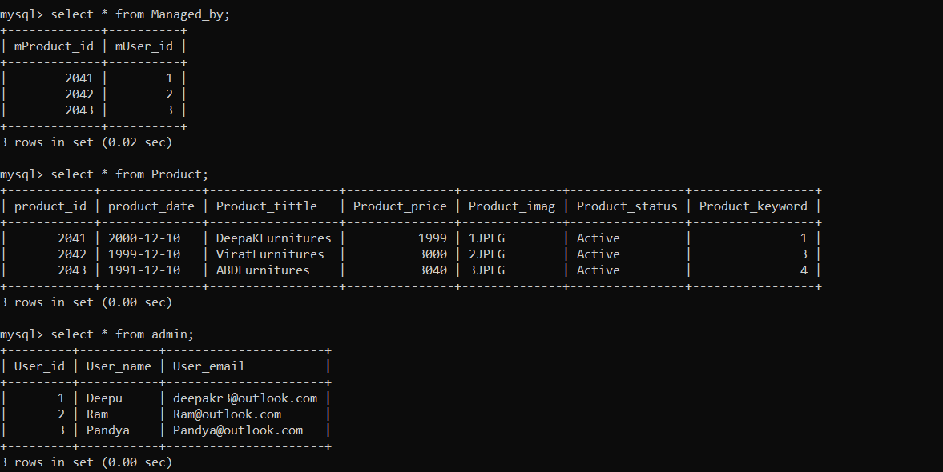

Then We tried to Update Managed\_by fuction’sMProduct\_id which is foreign key from Products.



System Displayed Error Message Saying Cannot Update a Child row.

By this we showed how update operations violate the schema based constraints by executing SQL commands.

**References**

Ponnaiah,P.,2007,Data Modeling Fundamentals,Wiley.